COMPUTER NETWORKS AND NETWORK PROGRAMMING
SKILL- 1
NAME:- K. Priyadarshini
Roll no:- 2520030067
Section no:- 2

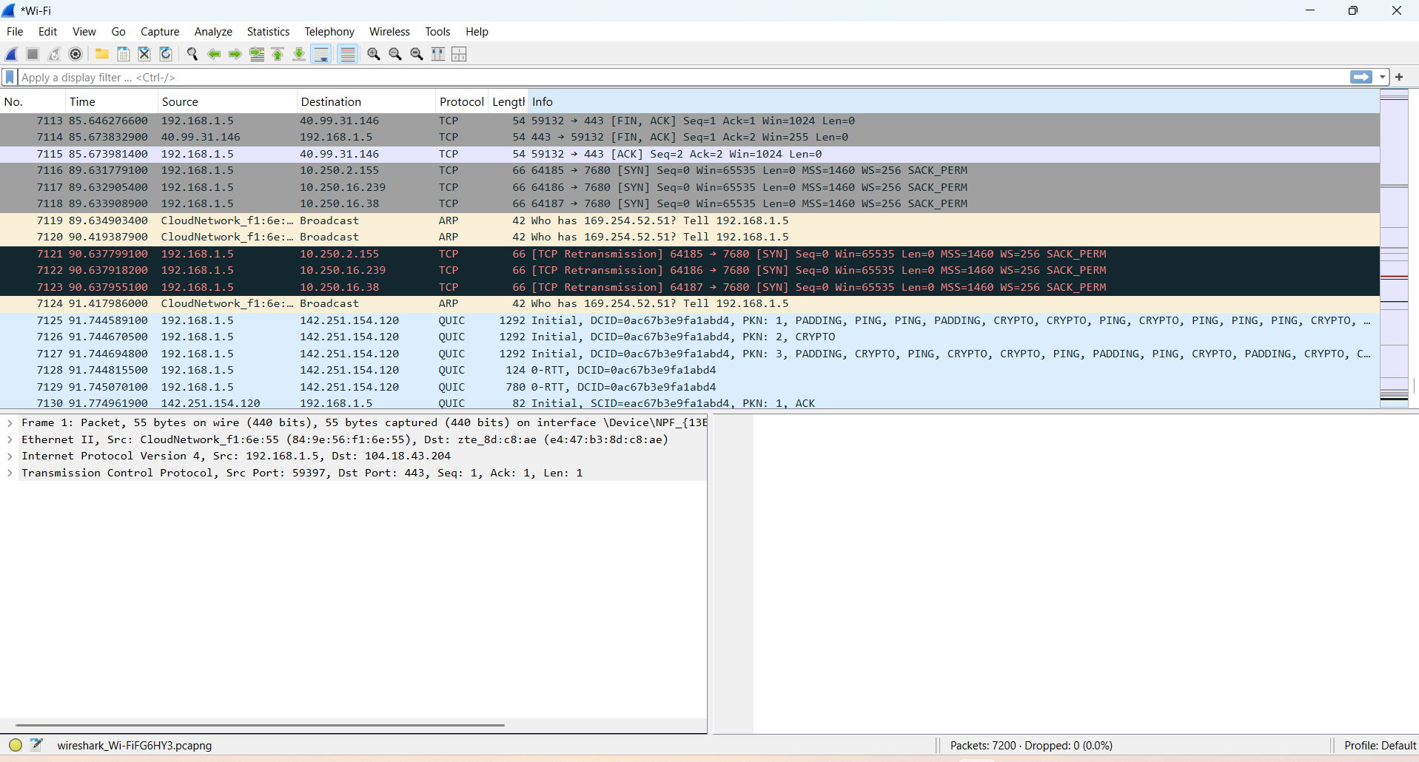
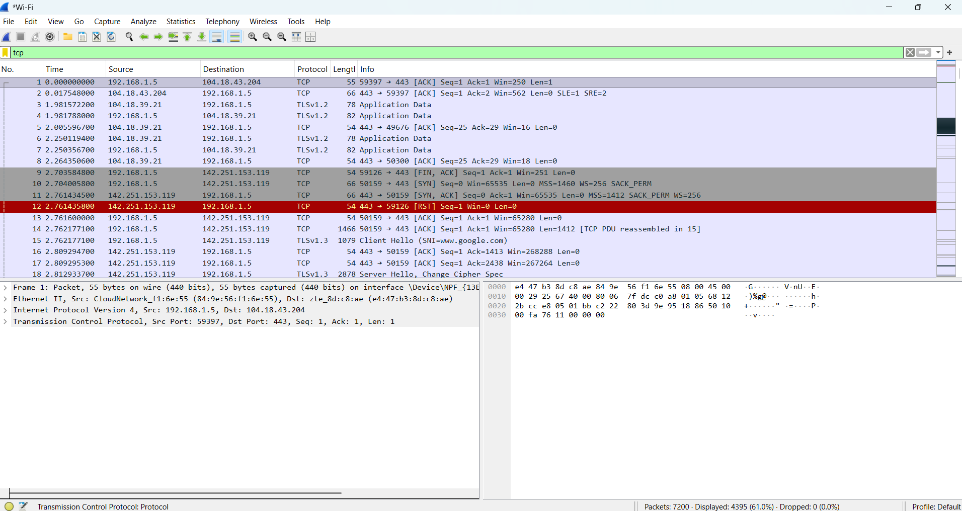
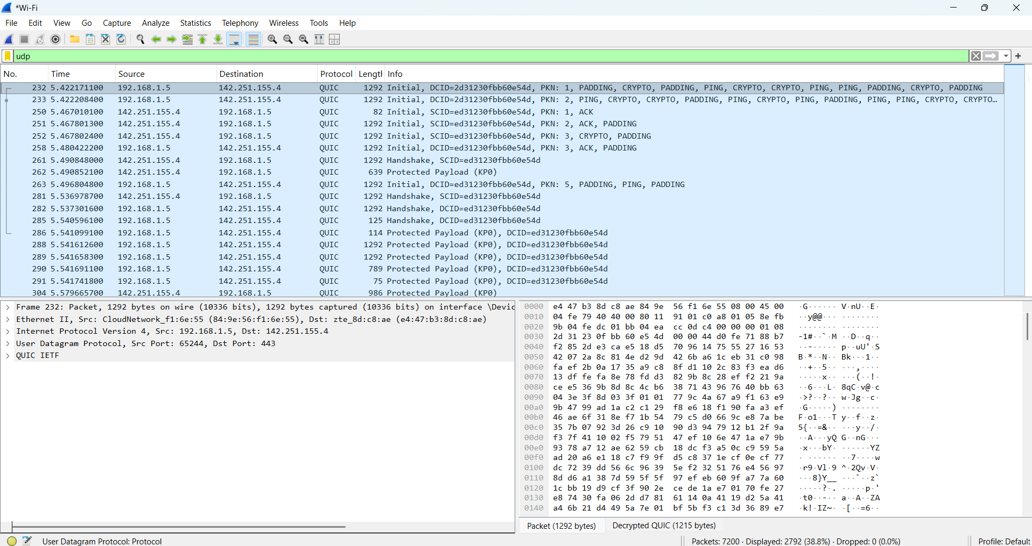
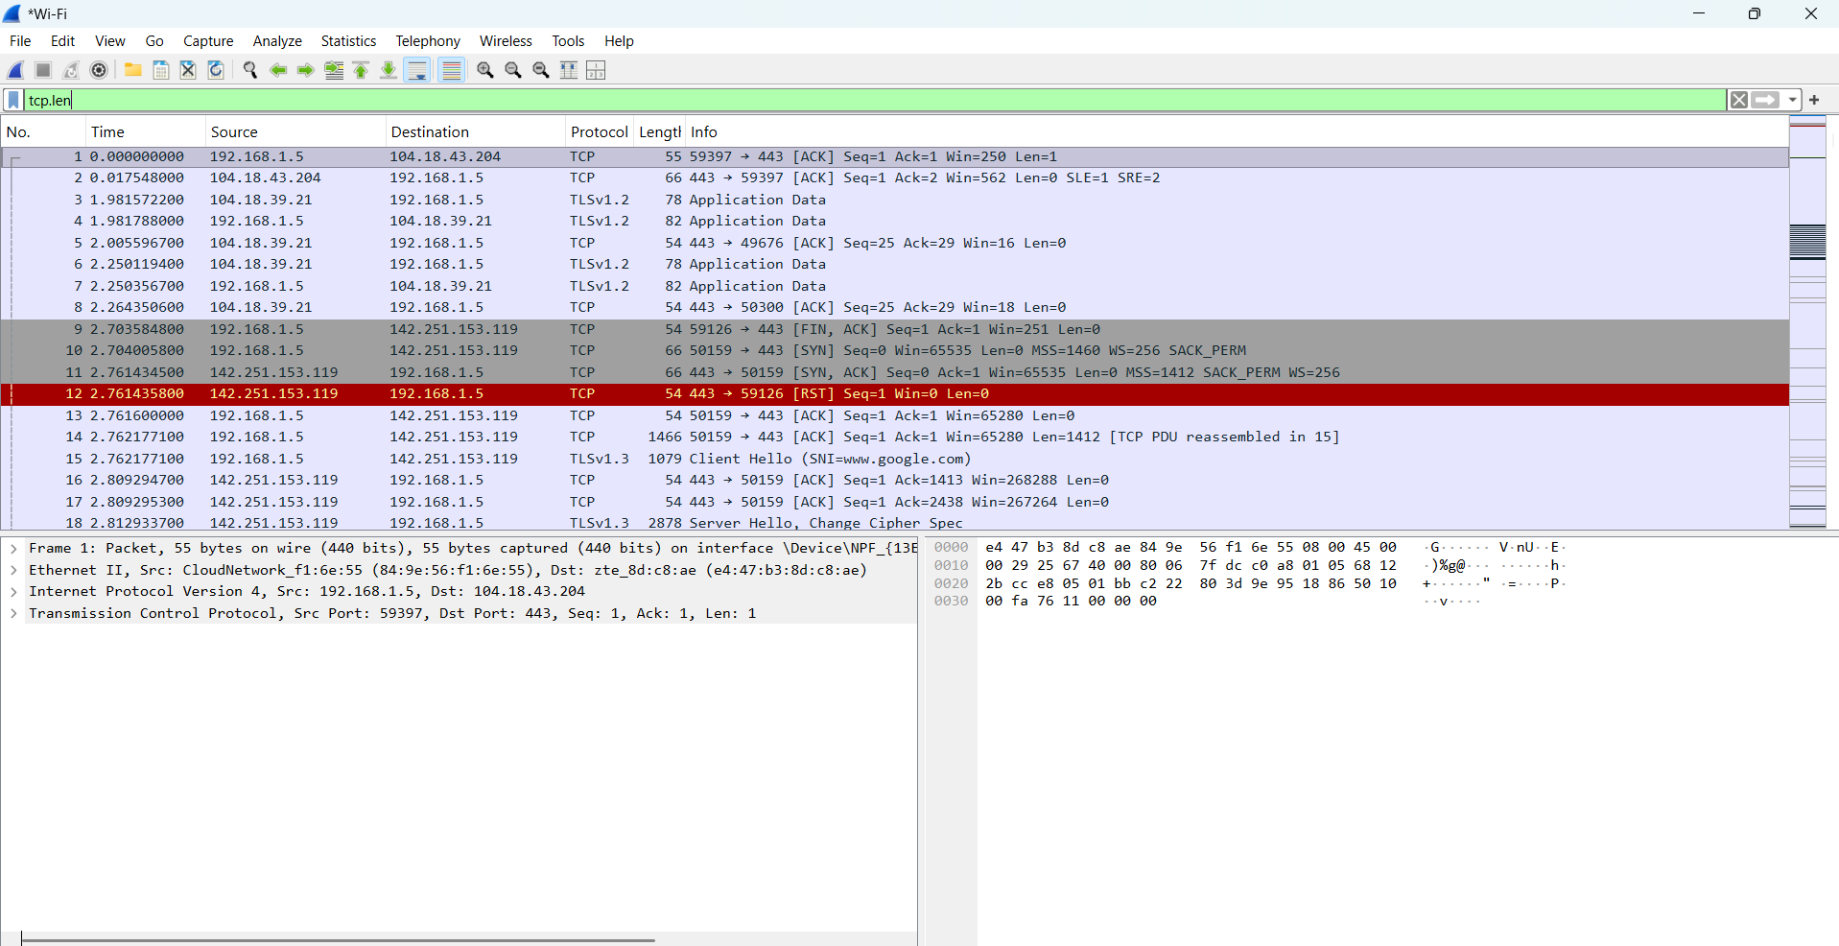

Calculations for TCP:-
Frame Number – 1
Frame Length – 55 bytes
Ethernet Header – 14 bytes
IPv4 Header – 20 bytes
TCP Header – 20 bytes
TCP Data Length(Len) - 1 byte
IPv4 Total Length – 41 bytes

= Ethernet Header + IPv4 Header + TCP Header + TCP Data Length
= 14 + 20 +20 + 1
= 55 bytes

Header Overhead:-
= 14 + 20 + 20
= 54 bytes
Payload Efficiency:-
= 1 / 55 * 100
= 1.82%

Calculations for UDP:-
Frame Number – 232
Frame Length – 1292 bytes
Ethernet Header – 14 bytes
IPv4 Header – 20 bytes
UDP Header – 8 bytes
IPv4 Total Length – 1278 bytes
UDP Payload – 1250 bytes

= Ethernet Header + IPv4 Header + UDP Header + UDP Payload
= 14 + 20 + 8 + 1250
= 1292 bytes
Header Overhead:-
= 14 + 20 + 8
= 42 bytes
Payload Efficiency:-
= 1250 / 1292 * 100
= 96.75%

Calculations for TCP.len > 0:-
Frame Number – 1
Frame Length – 57 bytes
Ethernet Header – 14 bytes
IPv4 Header – 20 bytes
TCP Header – 20 bytes
TCP Data Length(Len) - 3 bytes
IPv4 Total Length – 41 bytes
= Ethernet Header + IPv4 Header + TCP Header + TCP Data Length
= 14 + 20 +20 + 3
= 55 bytes
Header Overhead:-
= 14 + 20 + 20
= 54 bytes
Payload Efficiency:-
= 3 / 55 * 100
= 5.45%

